Name: Harsita Ashok
Reg No: 192521086
CSA1507 Cloud Computing and Big Data Analytics – Lab Experiments

EXPERIMENT 1
Aim :
To Create a simple cloud software application for Flight Reservation System using any
Cloud Service Provider to demonstrate SaaS include the necessary fields such as one
way, round trip, From, to, Departure, Departure, Travelers & Class, Fare Type,
International and Domestic Flights etc.

Procedure:
- Open a web browser and visit https://creator.zoho.com⁠�.
- Sign in to your Zoho account.
- Click Create New Application.
- Enter the application name (e.g., Student Management System) and click Create.
- Click + Create and select Form.
- Choose Blank Form.
- Enter the form name as Student Registration and click Create.
- Add the required fields: Student Name, Roll Number, Email, Mobile Number, Date of Birth, Department, Gender, and Address.
- Mark the required fields as Mandatory.
- Click Save or Done to save the form.
- Open the form in Live Mode.
- Enter sample student details and click Submit.
- Verify that the submitted data is stored in the generated report.

Implementation:
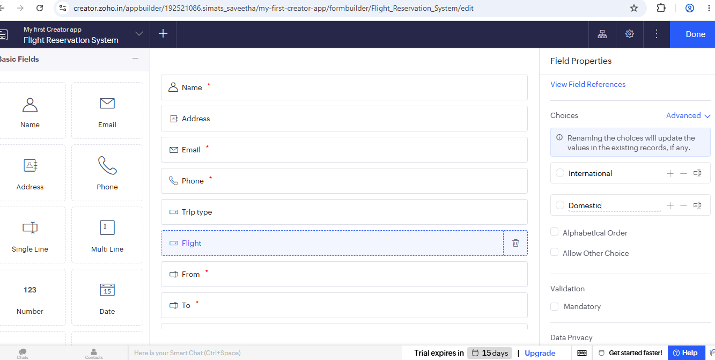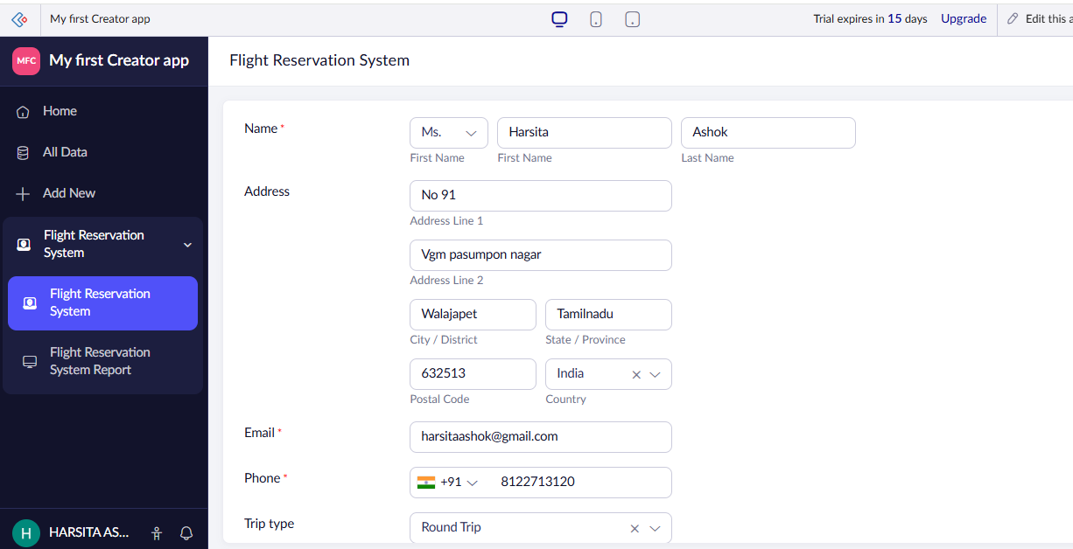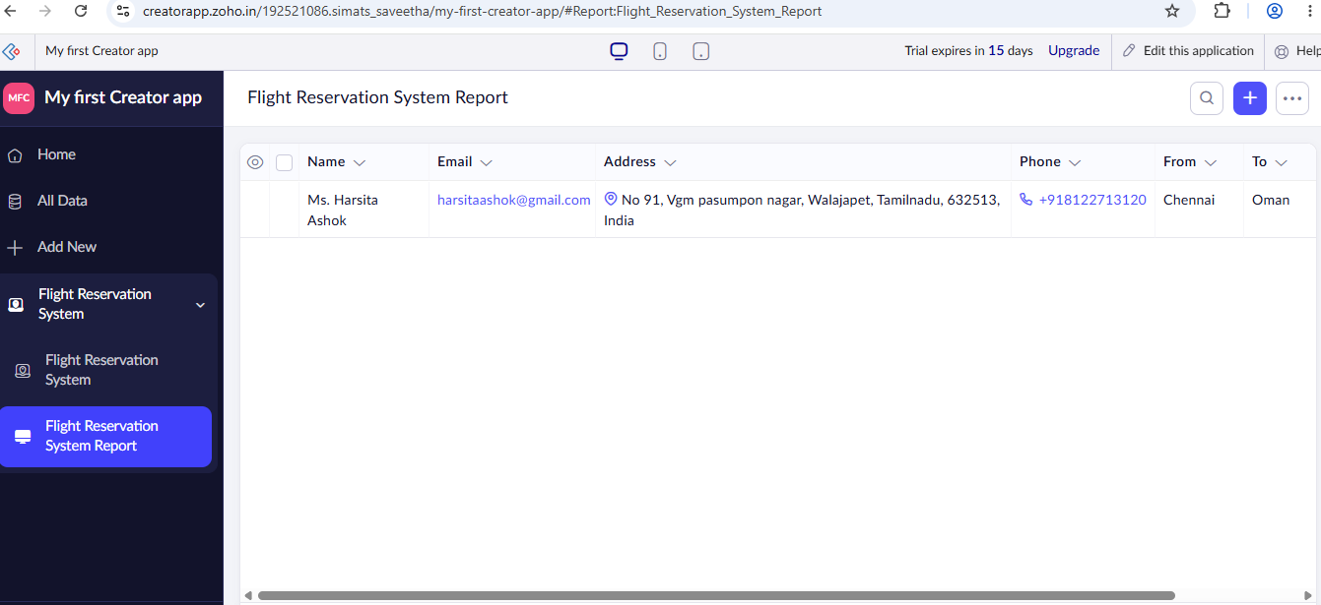

Result:
The cloud software application for flight reservation system was successfully created.

EXPERIMENT 2
Aim:
To Create a simple cloud software application for Property Buying & Rental process (In
Chennai city) using any Cloud Service Provider to demonstrate SaaS include the
necessary fields such as Buy, Rent, commercial, Rental Agreement , Rental Agreement,
Area, place, Range, property value etc.

Procedure:
- Open a web browser and visit https://creator.zoho.com⁠�.
- Sign in to your Zoho account.
- Click Create New Application.
- Enter the application name (e.g., Student Management System) and click Create.
- Click + Create and select Form.
- Choose Blank Form.
- Enter the form name as Student Registration and click Create.
- Add the required fields: Student Name, Roll Number, Email, Mobile Number, Date of Birth, Department, Gender, and Address.
- Mark the required fields as Mandatory.
- Click Save or Done to save the form.
- Open the form in Live Mode.
- Enter sample student details and click Submit.
- Verify that the submitted data is stored in the generated report

Implementation:

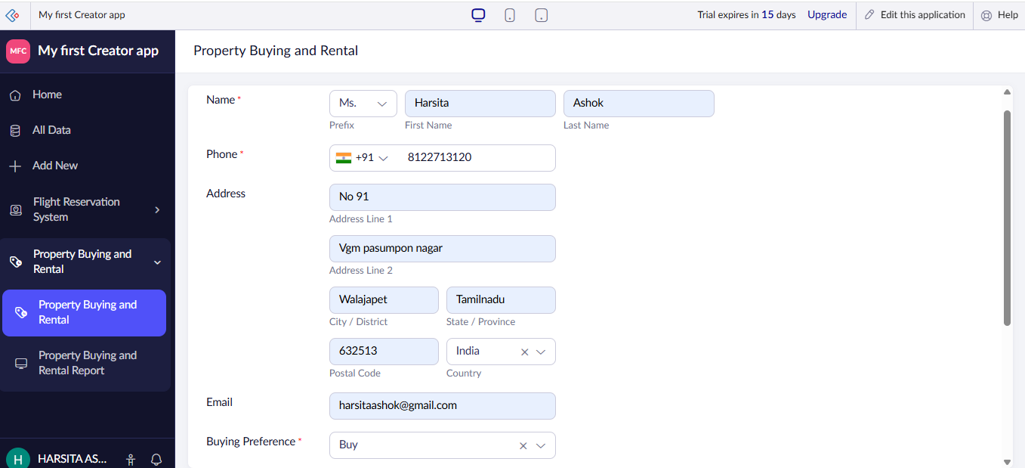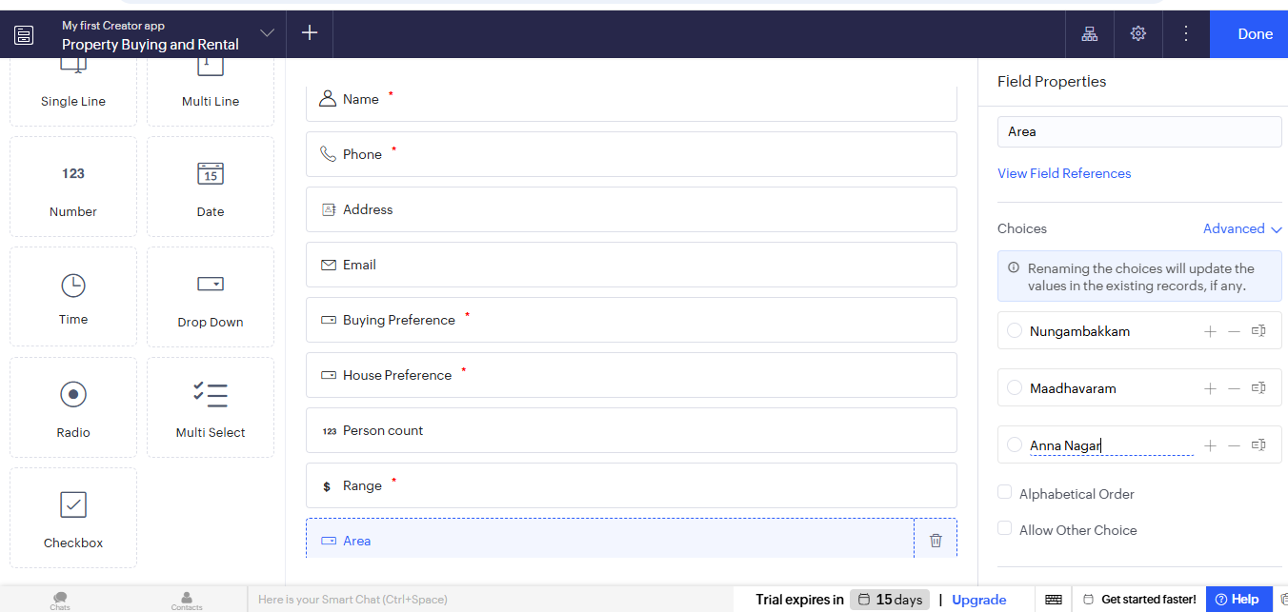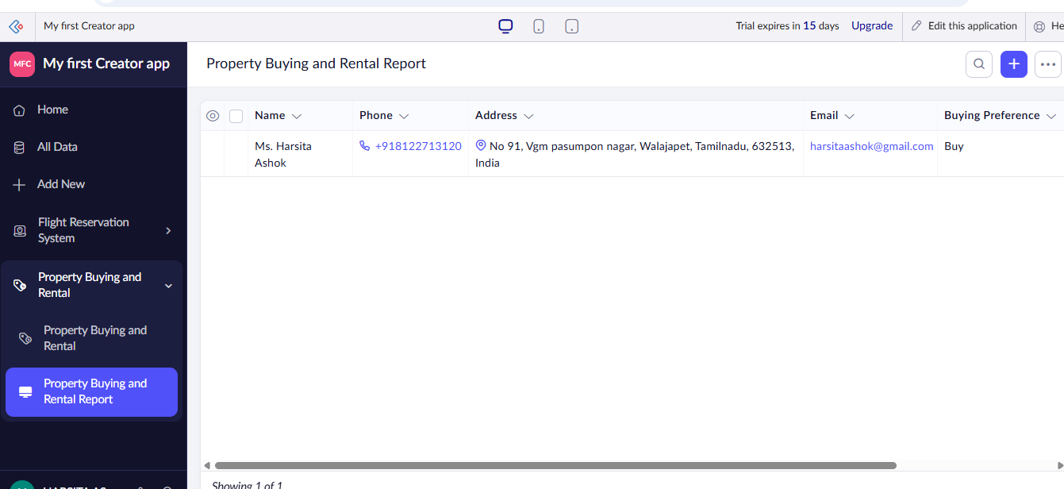
Result:
The cloud software application for property buying and rental was successfully created.

EXPERIMENT 3:
Aim:
Create a simple cloud software application for Car Booking Reservation System using
any Cloud Service Provider to demonstrate SaaS include the necessary fields such as
search for cabs, from, to, rental , out station, Package type, hours/Days etc.

Procedure:
- Open a web browser and visit https://creator.zoho.com⁠�.
- Sign in to your Zoho account.
- Click Create New Application.
- Enter the application name (e.g., Student Management System) and click Create.
- Click + Create and select Form.
- Choose Blank Form.
- Enter the form name as Student Registration and click Create.
- Add the required fields: Student Name, Roll Number, Email, Mobile Number, Date of Birth, Department, Gender, and Address.
- Mark the required fields as Mandatory.
- Click Save or Done to save the form.
- Open the form in Live Mode.
- Enter sample student details and click Submit.
- Verify that the submitted data is stored in the generated report

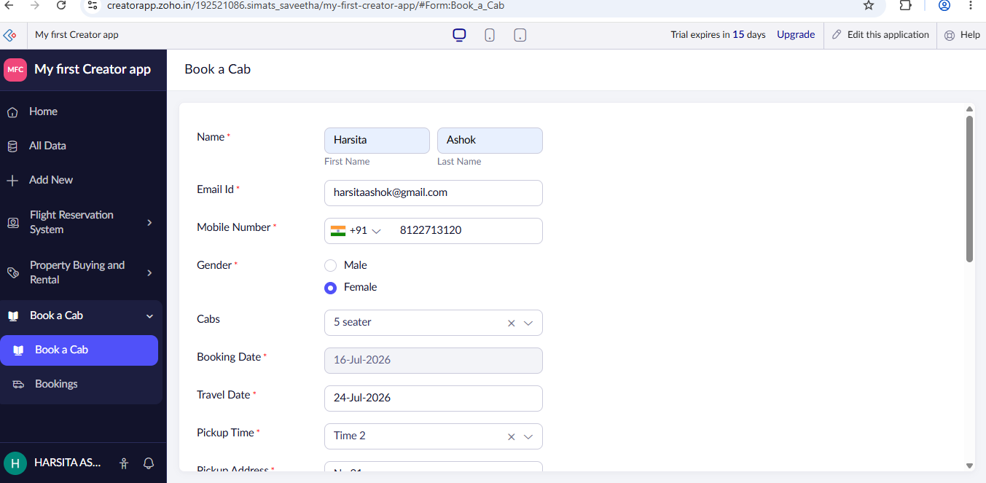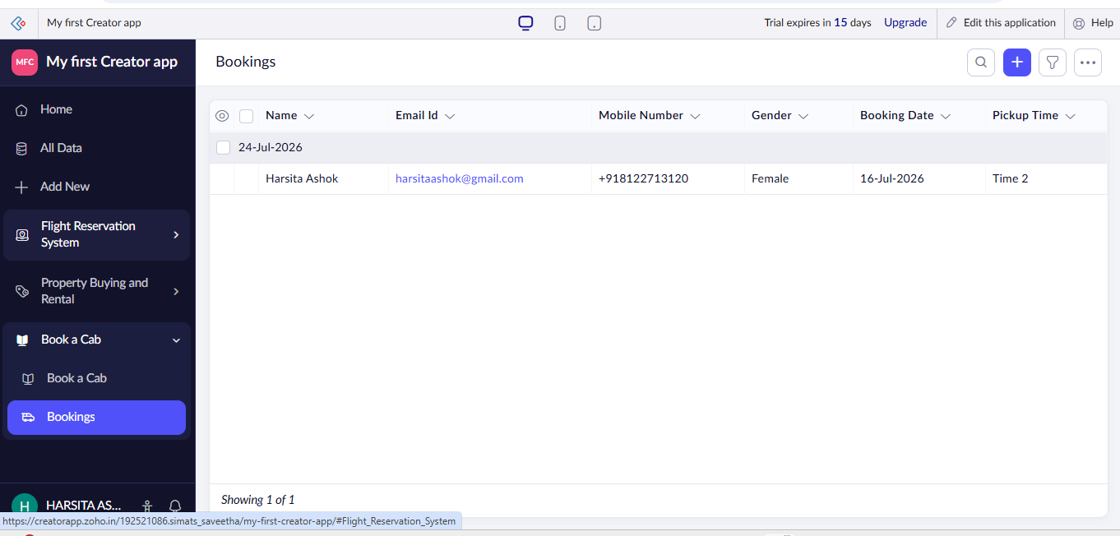

Result:
The cloud software application for cab booking has been successfully created.

EXPERIMENT 4:
Aim: Create a simple cloud software application for Library book reservation system for
SIMATS library using any Cloud Service Provider to demonstrate SaaS include the
necessary fields such as Title of the book, author, publications, Year, edition, no of
copies, Rack no, status (taken/returned) etc.

Procedure:
- Open a web browser and visit https://creator.zoho.com⁠�.
- Sign in to your Zoho account.
- Click Create New Application.
- Enter the application name (e.g., Student Management System) and click Create.
- Click + Create and select Form.
- Choose Blank Form.
- Enter the form name as Student Registration and click Create.
- Add the required fields: Student Name, Roll Number, Email, Mobile Number, Date of Birth, Department, Gender, and Address.
- Mark the required fields as Mandatory.
- Click Save or Done to save the form.
- Open the form in Live Mode.
- Enter sample student details and click Submit.
- Verify that the submitted data is stored in the generated report

Implementation:
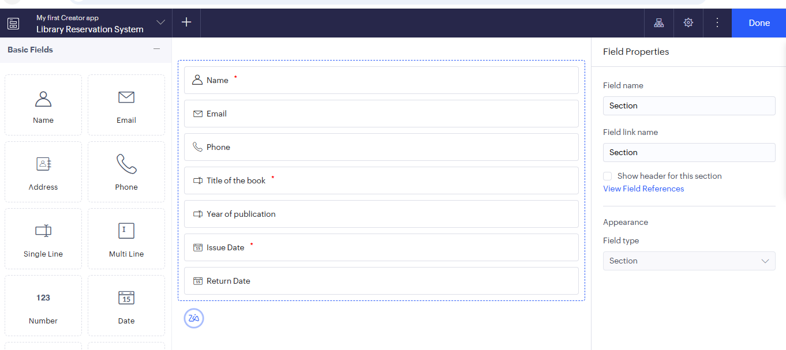
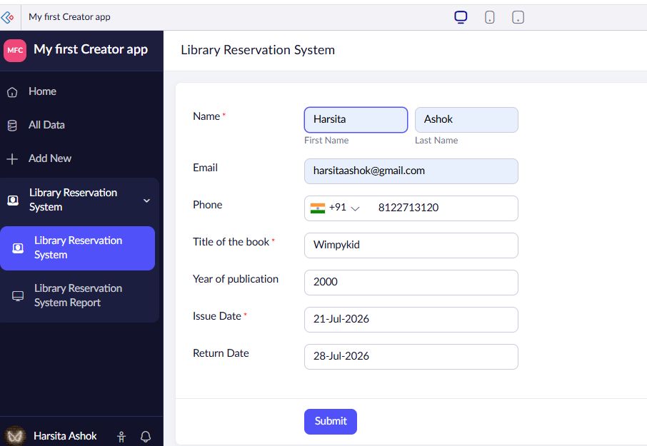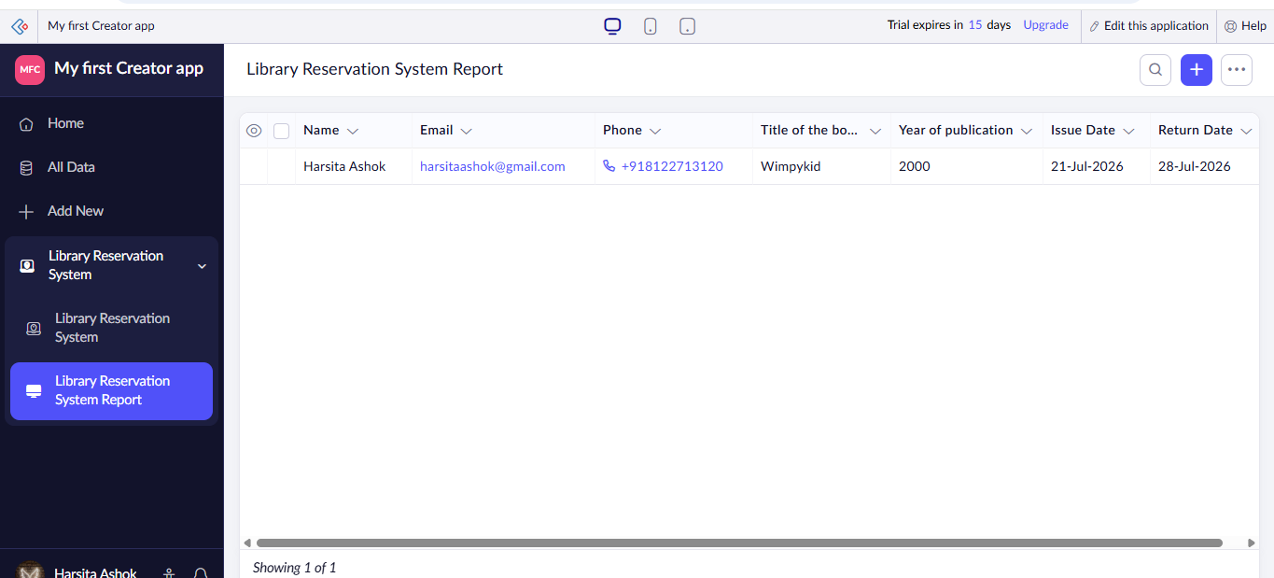

Result:
The cloud software application for Library Management System was successfully created.

EXPERIMENT 5:
Aim: Create a simple cloud software application for Mark Sheet Processing System using
any Cloud Service Provider to demonstrate SaaS include the necessary fields such as
name of the student, Reg no of the student , Subjects , Marks, Average, percentage,
rank, overall performance etc.

Procedure:
- Open a web browser and visit https://creator.zoho.com⁠�.
- Sign in to your Zoho account.
- Click Create New Application.
- Enter the application name (e.g., Student Management System) and click Create.
- Click + Create and select Form.
- Choose Blank Form.
- Enter the form name as Student Registration and click Create.
- Add the required fields: Student Name, Roll Number, Email, Mobile Number, Date of Birth, Department, Gender, and Address.
- Mark the required fields as Mandatory.
- Click Save or Done to save the form.
- Open the form in Live Mode.
- Enter sample student details and click Submit.
- Verify that the submitted data is stored in the generated report

Implementation:
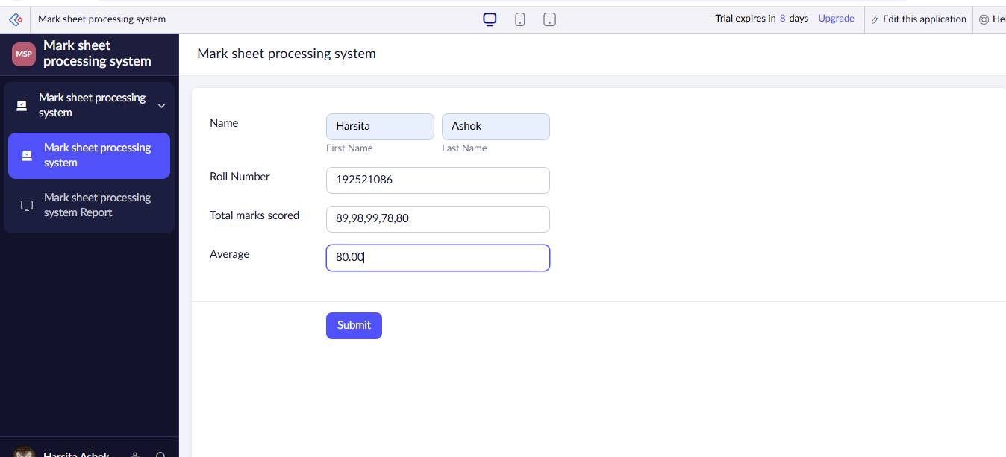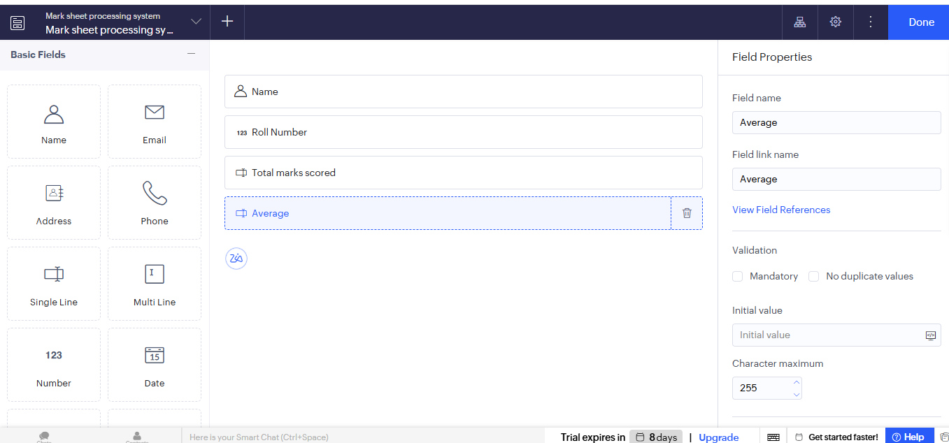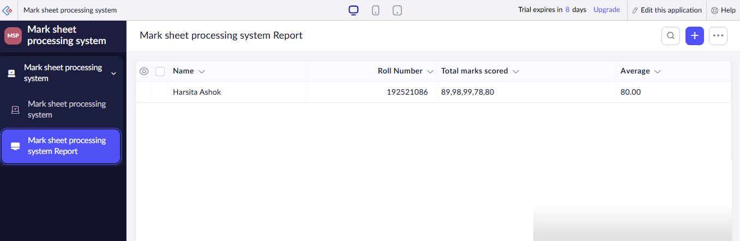

Result:
The cloud software application for Mark processing system was successfully created.

EXPERIMENT 6:
Aim: Create a simple cloud software application for Payroll Processing System using any
Cloud Service Provider to demonstrate SaaS include the necessary fields such as Name
of the employee, experience in present org , over all experience, basic pay, HRA, DA,
TA, net pay, gross pay etc.

Procedure:
- Open a web browser and visit https://creator.zoho.com⁠�.
- Sign in to your Zoho account.
- Click Create New Application.
- Enter the application name (e.g., Student Management System) and click Create.
- Click + Create and select Form.
- Choose Blank Form.
- Enter the form name as Student Registration and click Create.
- Add the required fields: Student Name, Roll Number, Email, Mobile Number, Date of Birth, Department, Gender, and Address.
- Mark the required fields as Mandatory.
- Click Save or Done to save the form.
- Open the form in Live Mode.
- Enter sample student details and click Submit.
- Verify that the submitted data is stored in the generated report

Implementation:
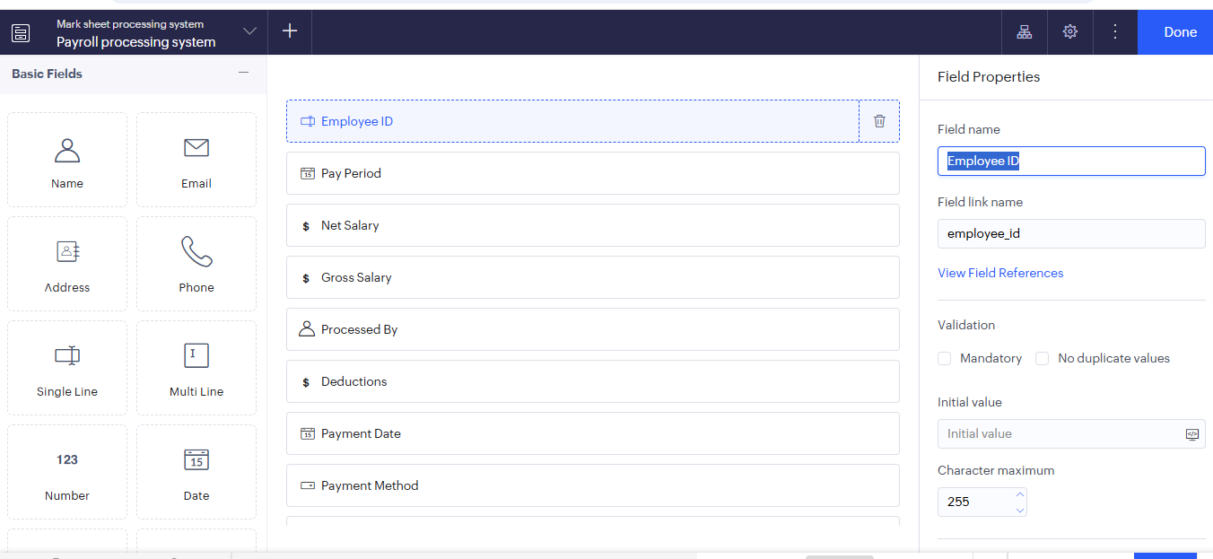
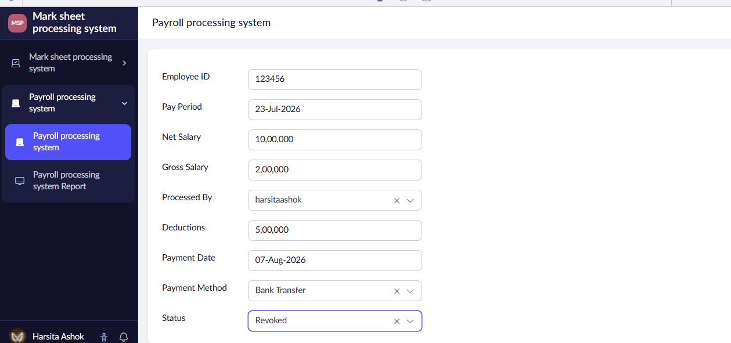
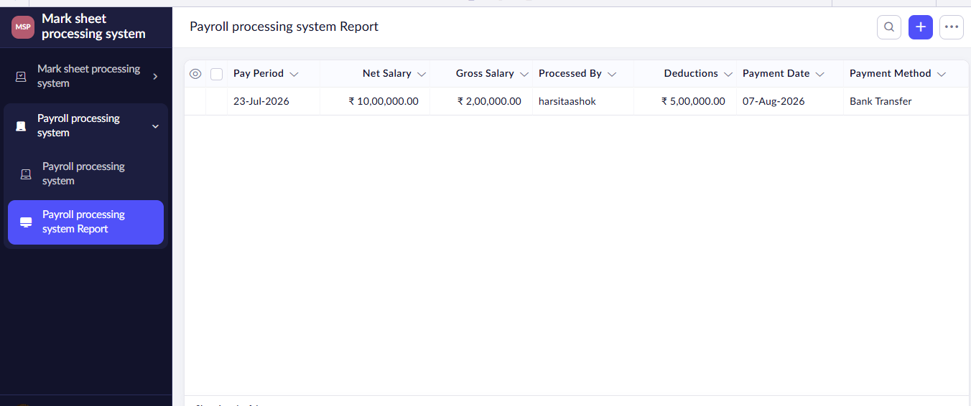

Result:
The cloud software application for Payroll Processing System was successfully created.

EXPERIMENT 7:
Aim: Create a simple cloud software application for Students Attendance System using any
Cloud Service Provider to demonstrate SaaS include the necessary fields such as name
of the students, course, present , Absent, course attendance, OD request, grade,
attendance percentage, etc.

Procedure:
- Open a web browser and visit https://creator.zoho.com⁠�.
- Sign in to your Zoho account.
- Click Create New Application.
- Enter the application name (e.g., Student Management System) and click Create.
- Click + Create and select Form.
- Choose Blank Form.
- Enter the form name as Student Registration and click Create.
- Add the required fields: Student Name, Roll Number, Email, Mobile Number, Date of Birth, Department, Gender, and Address.
- Mark the required fields as Mandatory.
- Click Save or Done to save the form.
- Open the form in Live Mode.
- Enter sample student details and click Submit.
- Verify that the submitted data is stored in the generated report

Implementation:
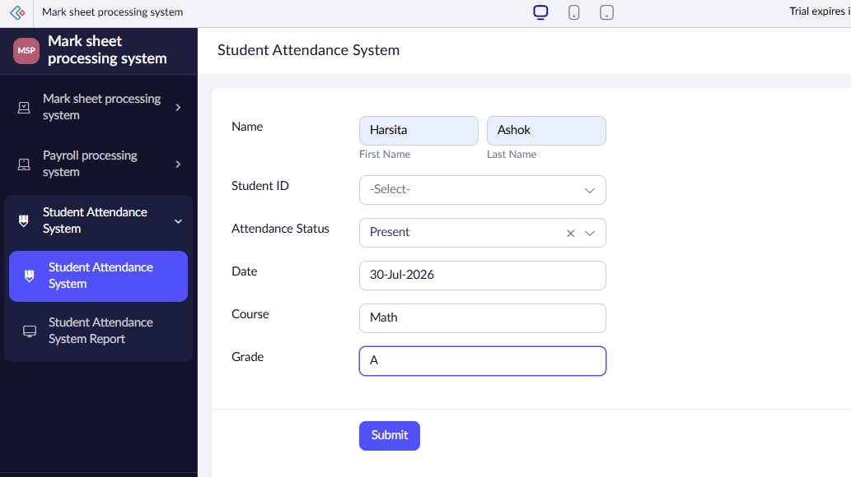
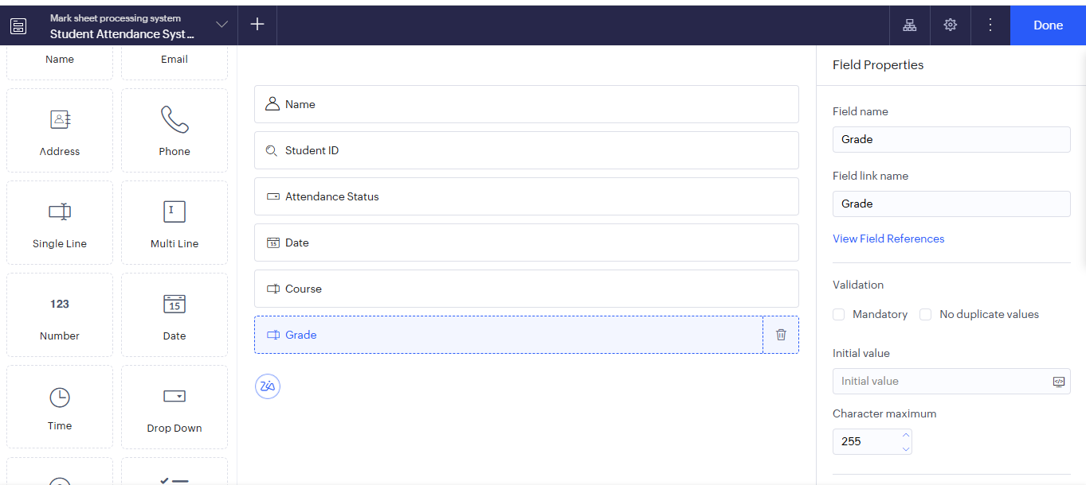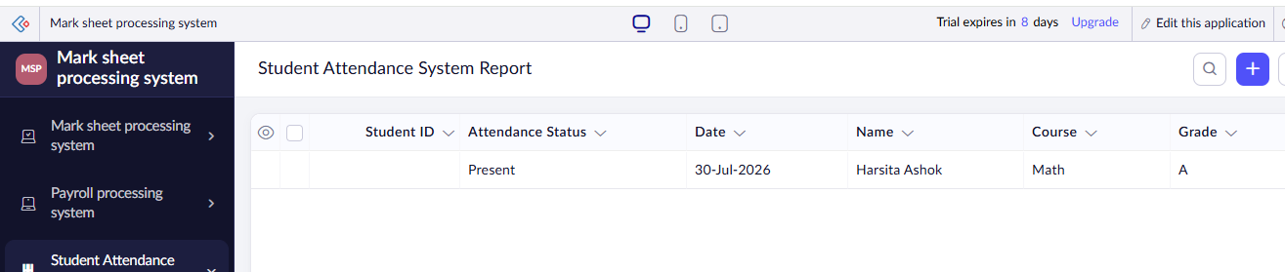

Result:
The cloud software application for Student attendance system was successfully created.

EXPERIMENT 8:
Aim: Create a simple cloud web application for student counselling system using any Cloud Service Provider to demonstrate SaaS with the fields of student name, age, address, phone, subjects studied, Year of passing, percentage of marks, domain interest, etc.

Procedure:
- Open a web browser and visit https://creator.zoho.com⁠�.
- Sign in to your Zoho account.
- Click Create New Application.
- Enter the application name (e.g., Student Management System) and click Create.
- Click + Create and select Form.
- Choose Blank Form.
- Enter the form name as Student Registration and click Create.
- Add the required fields: Student Name, Roll Number, Email, Mobile Number, Date of Birth, Department, Gender, and Address.
- Mark the required fields as Mandatory.
- Click Save or Done to save the form.
- Open the form in Live Mode.
- Enter sample student details and click Submit.
- Verify that the submitted data is stored in the generated report

Implementation:
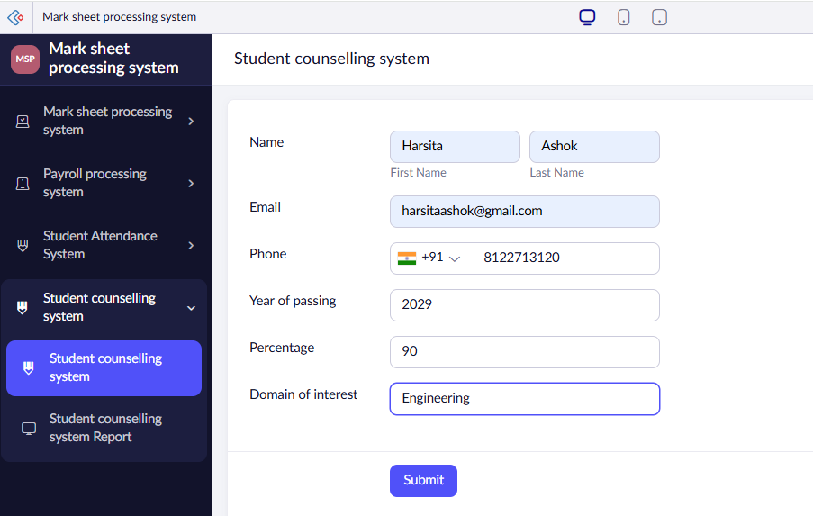
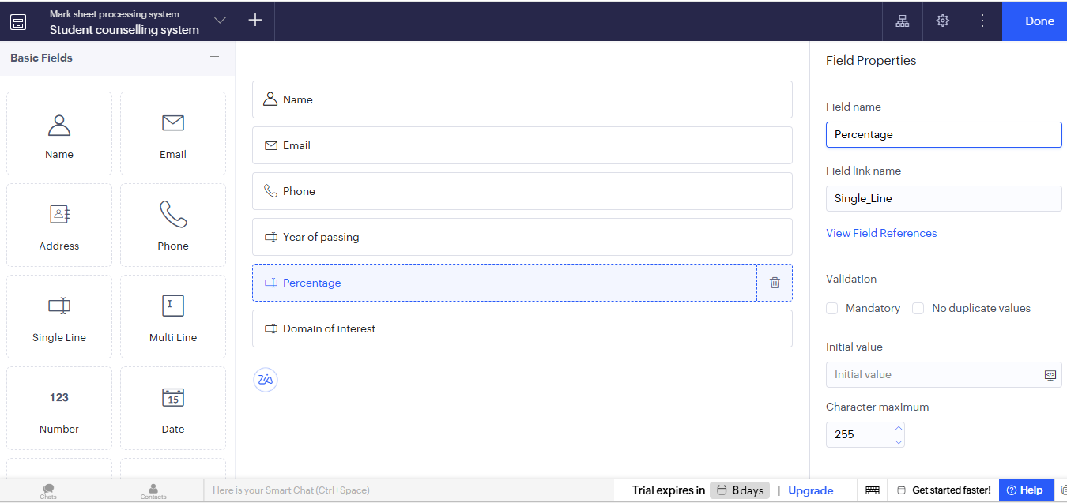
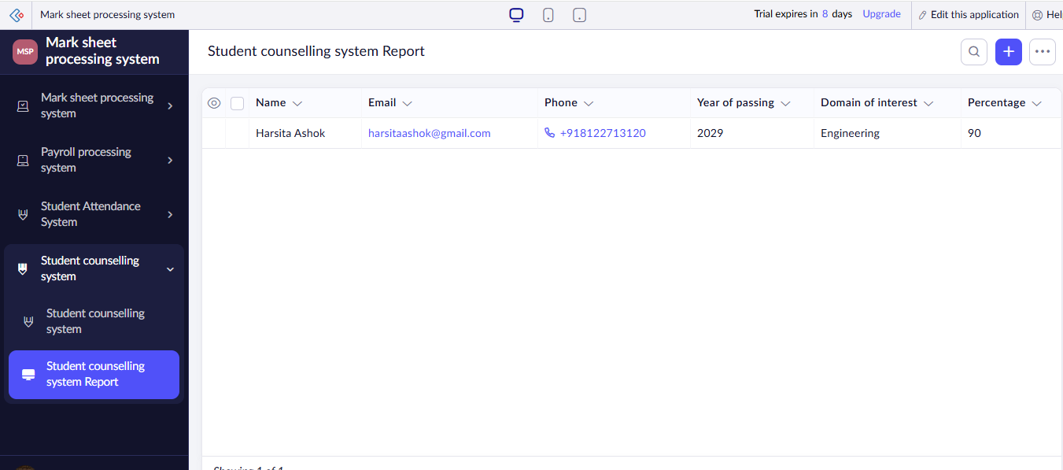

Result:
The cloud software application for Student counselling system was successfully created.

EXPERIMENT 9:
Aim: Create a simple cloud software application for Hospital information system for
SIMATS Hospital using any Cloud Service Provider to demonstrate SaaS with fields of
patient name, age, address, phone, email, Attender name, attender phone, doctor name,
diseases, etc.

Procedure:
- Open a web browser and visit https://creator.zoho.com⁠�.
- Sign in to your Zoho account.
- Click Create New Application.
- Enter the application name (e.g., Student Management System) and click Create.
- Click + Create and select Form.
- Choose Blank Form.
- Enter the form name as Student Registration and click Create.
- Add the required fields: Student Name, Roll Number, Email, Mobile Number, Date of Birth, Department, Gender, and Address.
- Mark the required fields as Mandatory.
- Click Save or Done to save the form.
- Open the form in Live Mode.
- Enter sample student details and click Submit.
- Verify that the submitted data is stored in the generated report

Implementation:
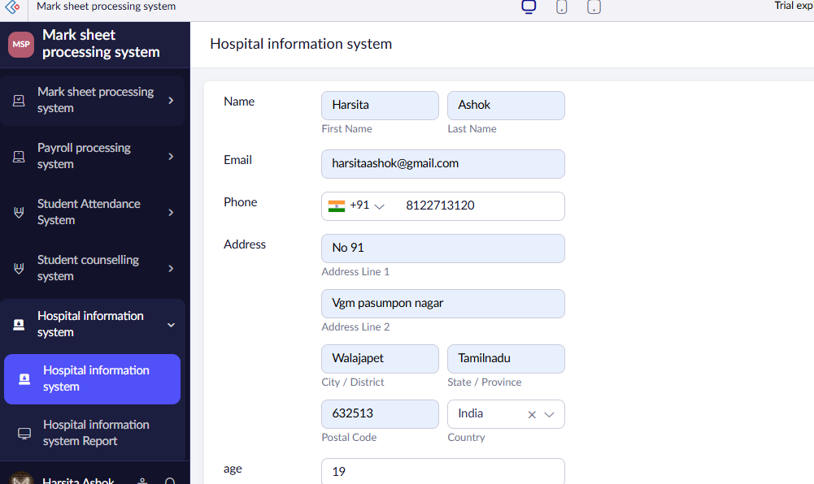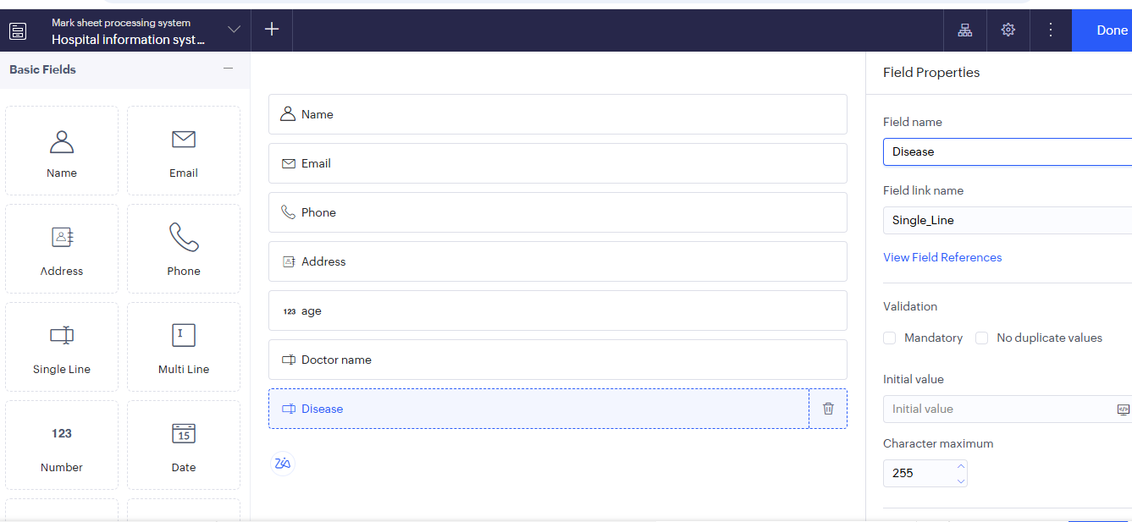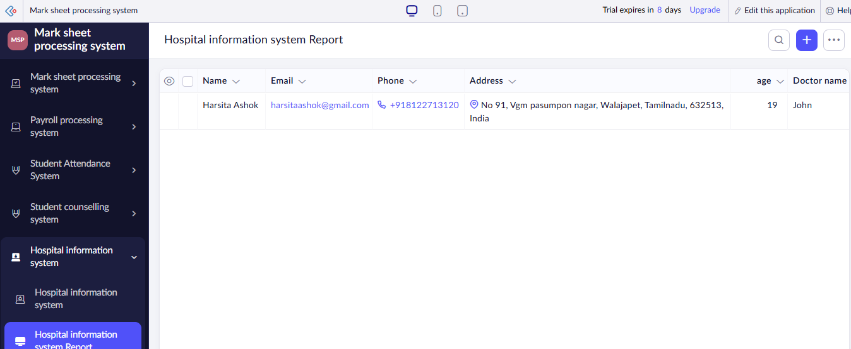

Result:
The cloud software application for Hospital information system was successfully created.

EXPERIMENT 10:
Aim: Create a simple cloud software application to run a c program to display the student
information using any Cloud Service Provider to demonstrate SaaS with the template
of student name, reg no, address, phone, age, courses, grades and attendance report,
progress report, Semester mark sheet forms

Procedure:
- Open a web browser and visit https://creator.zoho.com⁠�.
- Sign in to your Zoho account.
- Click Create New Application.
- Enter the application name (e.g., Student Management System) and click Create.
- Click + Create and select Form.
- Choose Blank Form.
- Enter the form name as Student Registration and click Create.
- Add the required fields: Student Name, Roll Number, Email, Mobile Number, Date of Birth, Department, Gender, and Address.
- Mark the required fields as Mandatory.
- Click Save or Done to save the form.
- Open the form in Live Mode.
- Enter sample student details and click Submit.
- Verify that the submitted data is stored in the generated report

Implementation:
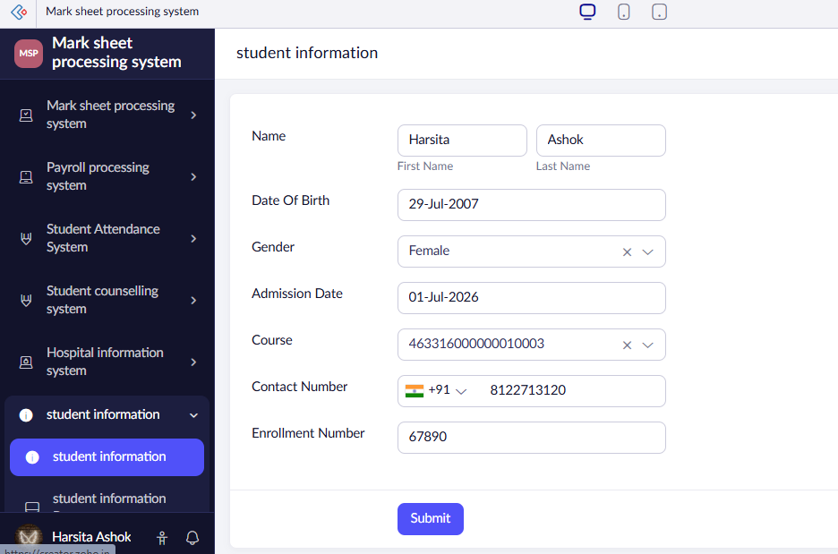
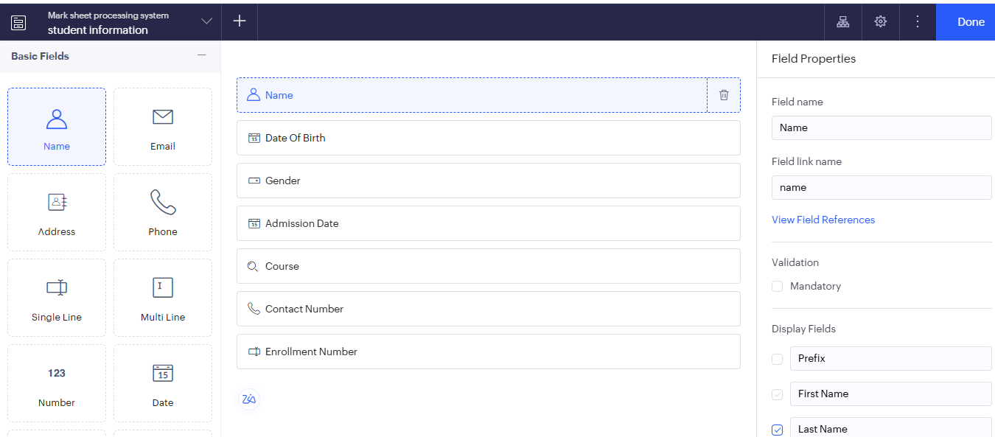
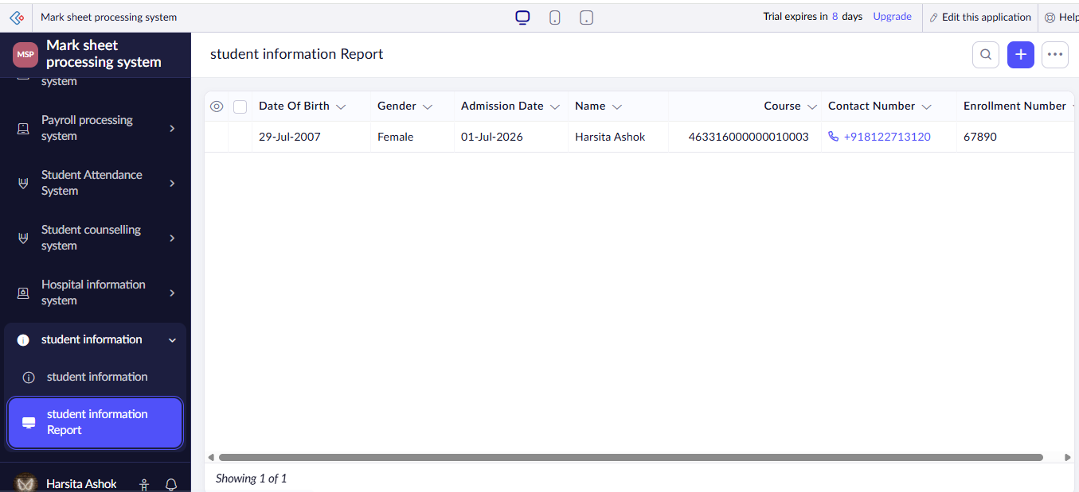

Result:
The cloud software application to run a c program to display the student information was successfully created.

EXPERIMENT 11:
Aim: Create a simple cloud software application for online super market using
any Cloud Service Provider to demonstrate SaaS with the template of
customer name, address, phone, email, items, quantity etc. with the item
classification form.

Procedure:
- Open a web browser and visit https://creator.zoho.com⁠�.
- Sign in to your Zoho account.
- Click Create New Application.
- Enter the application name (e.g., Student Management System) and click Create.
- Click + Create and select Form.
- Choose Blank Form.
- Enter the form name as Student Registration and click Create.
- Add the required fields: Student Name, Roll Number, Email, Mobile Number, Date of Birth, Department, Gender, and Address.
- Mark the required fields as Mandatory.
- Click Save or Done to save the form.
- Open the form in Live Mode.
- Enter sample student details and click Submit.
- Verify that the submitted data is stored in the generated report

Implementation:

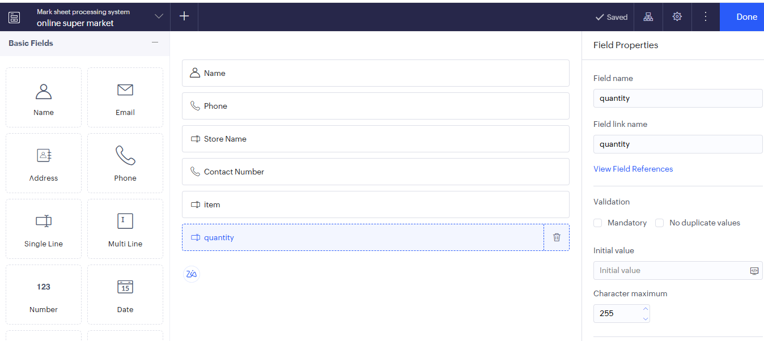
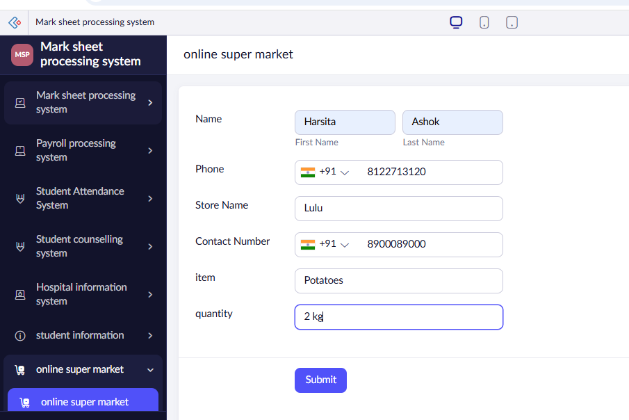
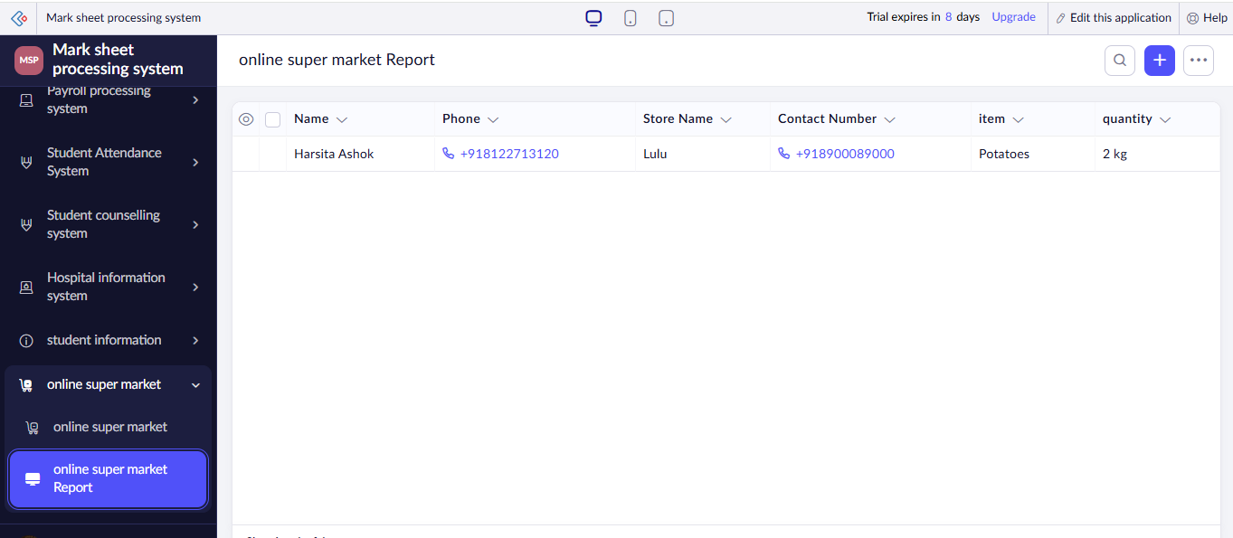

Result:
The cloud software application for online super market was successfully created.

